Post-Impressionism Day 1
Art 2

Post-Impressionism lasted between __________________

Cezanne was born in France in ___________  Is known for painting _______________, portraits, and _____________________.  Used ______________ shapes in his work. He worked _________________.  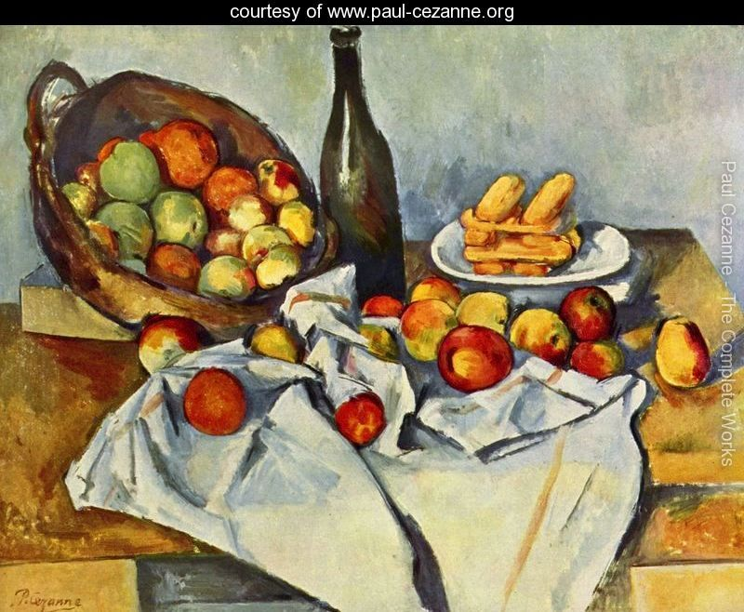  Died of ________________________ in ______________. | Nation of ______________ purchased Cezanne’s Card Players for __________ million dollars in 2012. It was the most money spent at auction at that date.

George Seurat was born in ______________  Pointillism- creating art using many ________  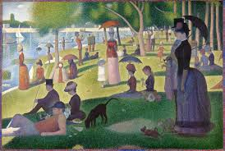  __________________ Afternoon on the Island of La Grand Jatte  took _____ years to complete  _______ ft wide  Seurat’s Art Theory  Happiness=___________colors  __________lines  Calm=________________colors  ________________lines  Sadness=________________colors  ________________lines  Died at age ______________ from __________________ | Henri de Toulouse Latrec  Born ______________  Parents were _____________________  suffered from congenital health defects from _______________  Latrec was short because he ___________ thigh bones his legs stopped ____________  He was only _____________  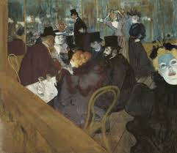  painted _______________  __________ on people  Because he was made fun of his entire life he turned to ___________________  to ensure he always had liquor he ____________________________________  Died at age ________________  from ________________________________

