Name: Impressionism 2
Renoir was born ______________  Had an affair with one of his _____________  She had his child but he ______________ acknowledged the child.  Married his longtime girlfriend Aline in ____________. He was 49.  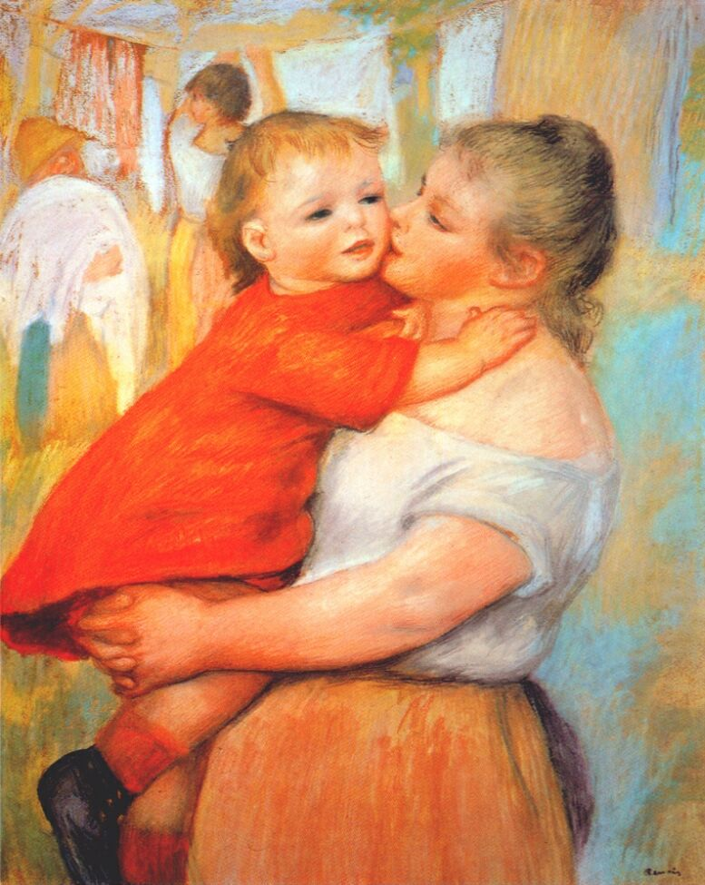  Painted until __________________ but he had rhumatoid arthritis that _______________ his fingers and made it hard.  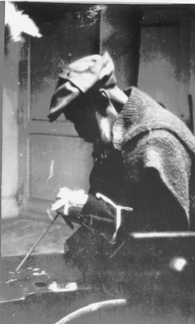 | Degas was born in ______________  _________________ was the all power art critics who decided what was and wasn’t art.  Degas met Manet and the two bonded over their ________________ of the Salon.  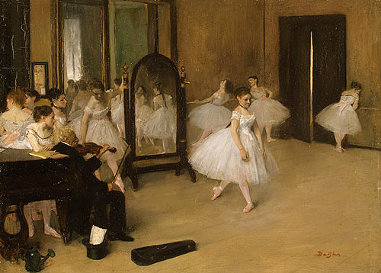  Degas painted everyday life of the __________________ mostly ballet dancers and women.  Unlike the other impressionists he painted ____________________  Degas began to lose his ___________ due to retinal disease.  Why are some people unsure of whether Degas’ paintings look the way he intended them to? ___________________________  ___________________________________

