Name_________________
German Expressionism

Movement took place between_____________  Art should express ___________ rather than the ________________  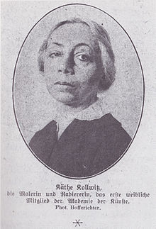  Kathe Kollwitz  focused on ____________________  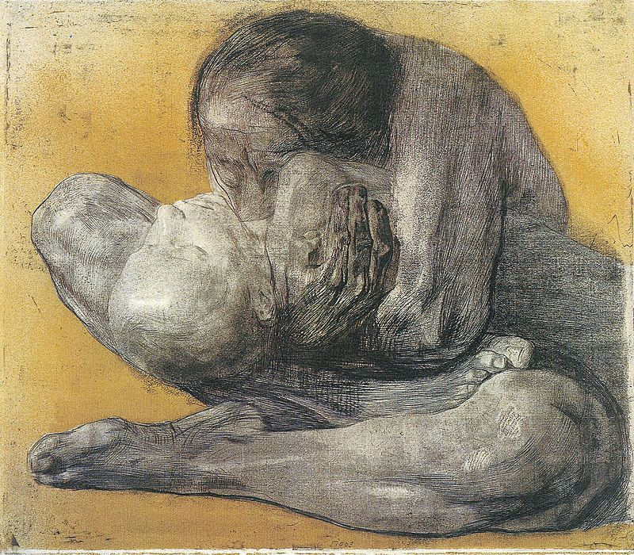  Suffered from ______________________ syndrome as a child  Married a _____________, which allowed her to work closely with the lower class | World War 1- lost a _______________  Called for the end of the war  World War 2- was forced to resign from her position at ______________  Art was __________________ from museums  Her husband and her were threatened by ____________________  ________________ was killed in the war  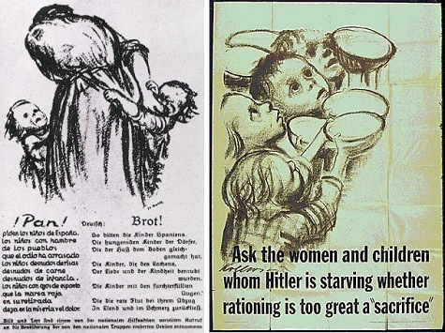  Nazi’s used her work in Women’s Socialist Magazine but ________________________________  US used her work as propaganda to promote ___________________

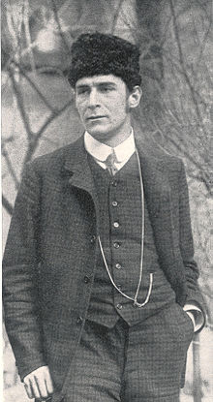Born ________________  Was inspired by ______________________  Was released from duty in the army, but _____________________ before the orders reached him.  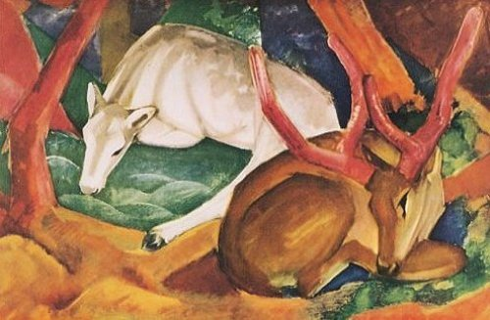  He gave an ______________________ meaning to the colors he used.  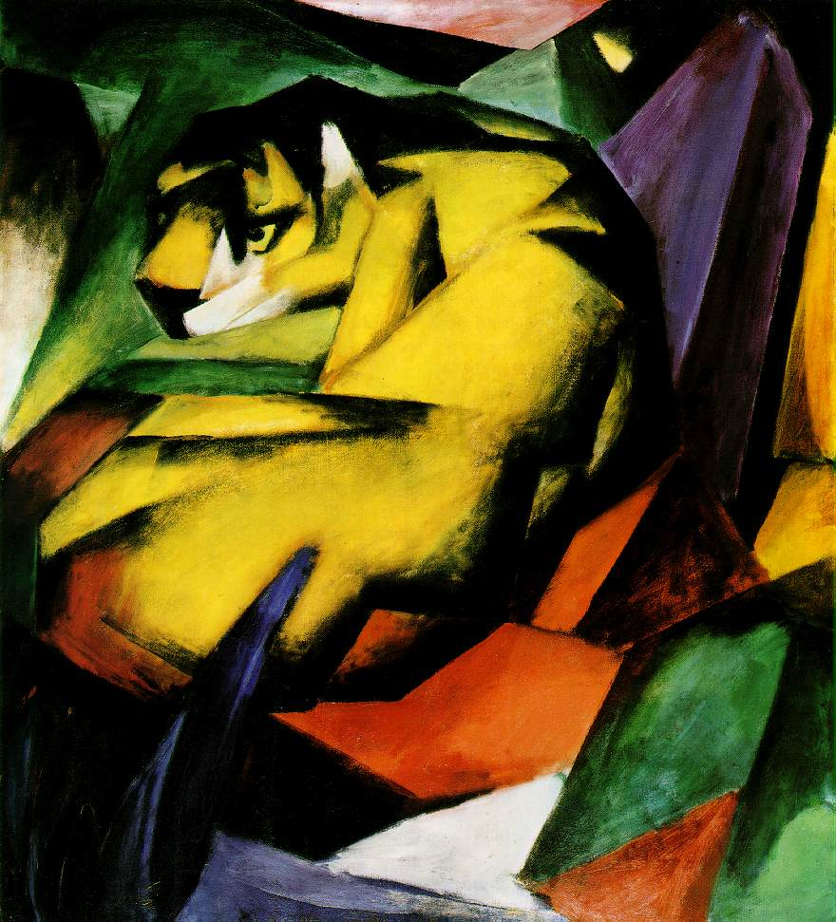  When the Nazis came to power he was labelled _______________. | ___________ of his works were removed from museums.  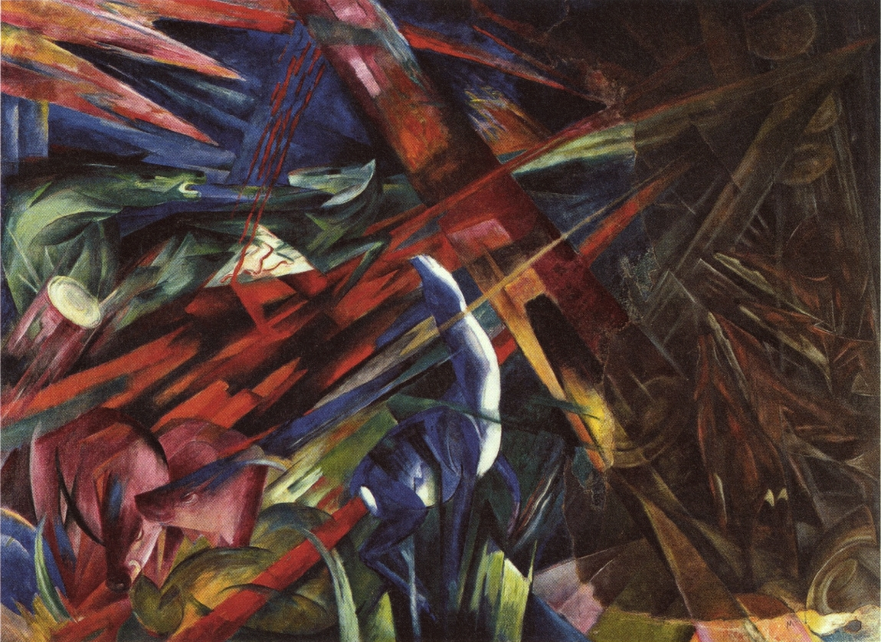  The Fate of the Animals  Depicted animals ________________  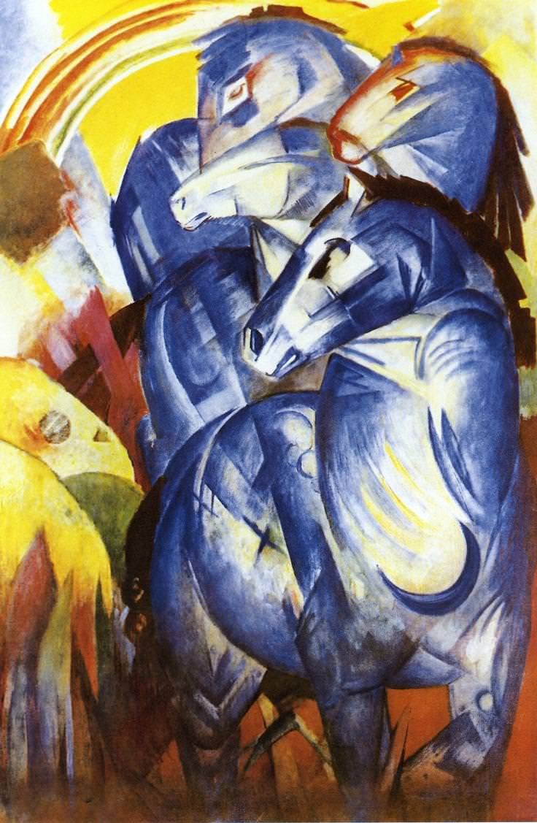  Horse Tower  Considered his _______________  has been missing since ____________

