Name_________
Art 1
Early Expressionism Notes

Expressionism- Portraying _____________ through distorting ___________ and _____________  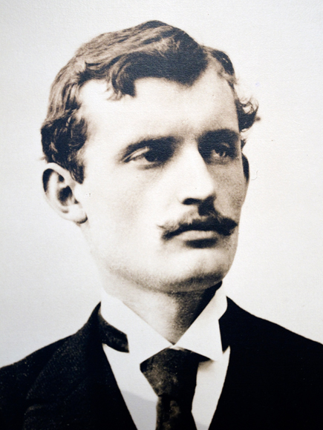1863-____________  Mother and Sister died of ____________  Brother died at age ___________  Father was fanatically ______________  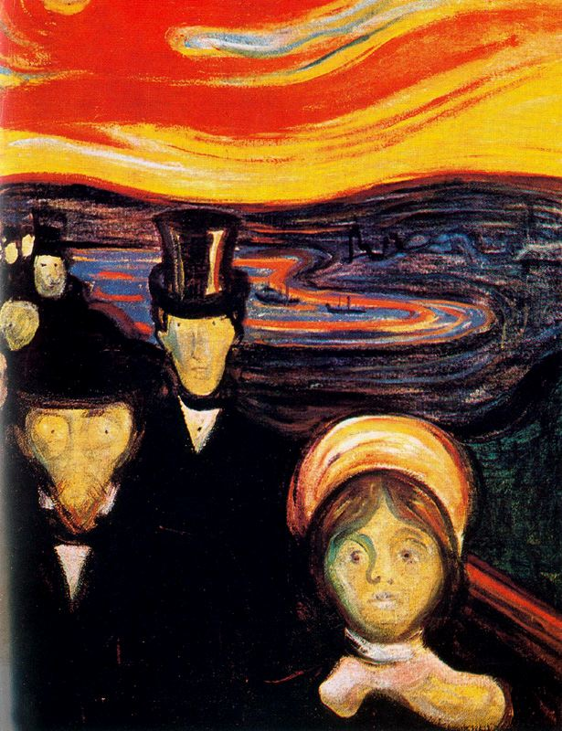  Why were his psychological problems good for his art?  “I want to paint pictures that will make people take off their hats in awe, the way they do in church.” Why would he make this comparison? | 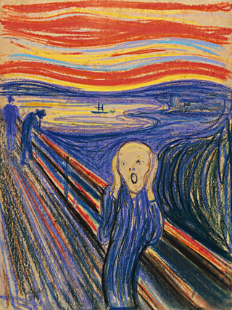Represents ________________________________  What would happen to the painting if the lines were smooth?  In 2012, it sold for _________________  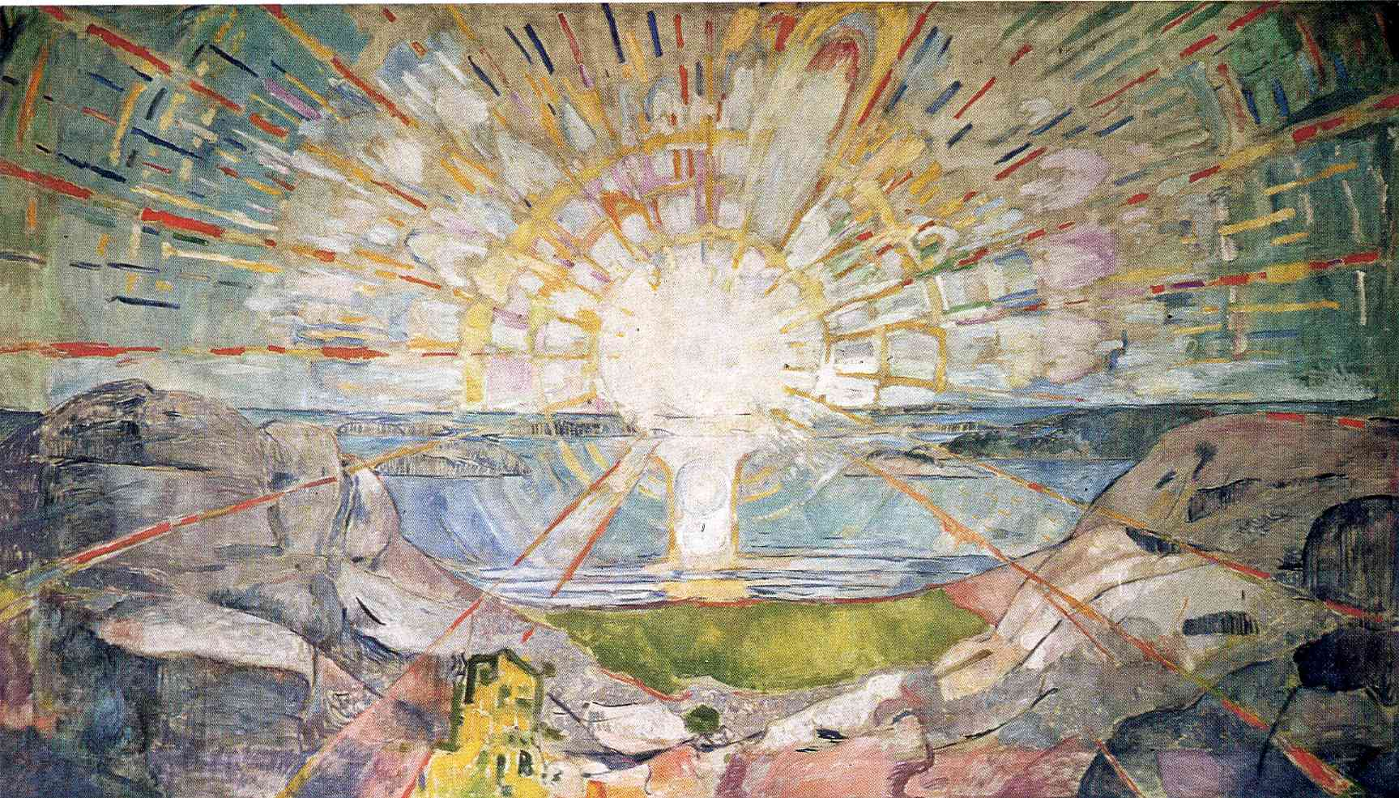  What emotion(s) does “The Sun” suggest? Why?  After his nervous breakdown, why is his work less moving?

