Name___________
Date___________
Art Notes
The Birth of Photography
The first photo was taken in 1828 and of a _________________________________  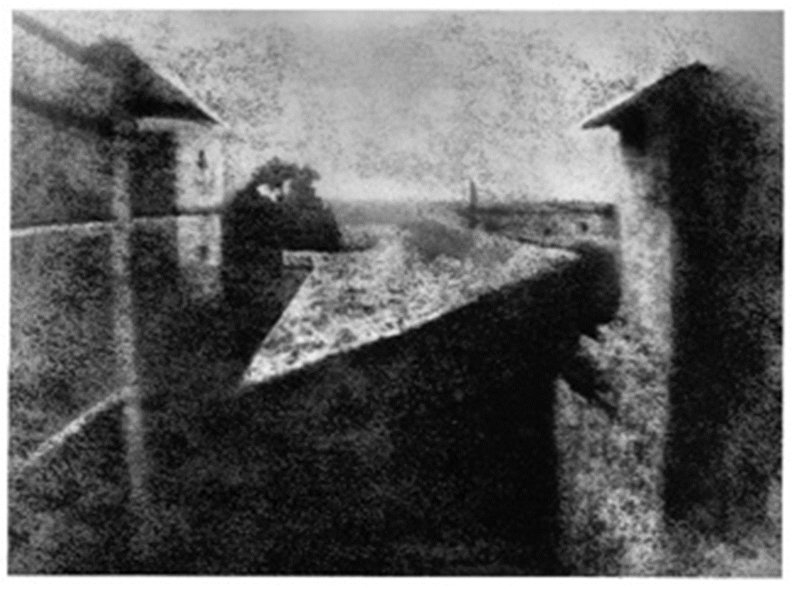  The first picture of a Human was taken in _____________________ and was of a man.  The man was sitting still to have his _____________________.  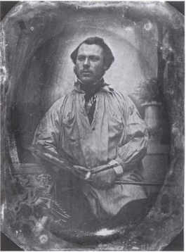  Types of Photography  _________________photography began in 1858. It was pictures of places. It was important because it was the first time the “world ____________________________”  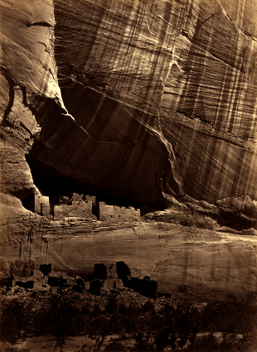 | War photography began during _____________________________. Mathew __________ is famous for taking 7,000 _______________ of the civil war.  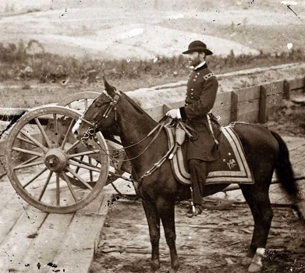  Documentary Photography was made famous by ____________________ in his book How the Other Half Lives in 1890. His work was important because it led to the first __________________ to reform housing codes and labor laws.  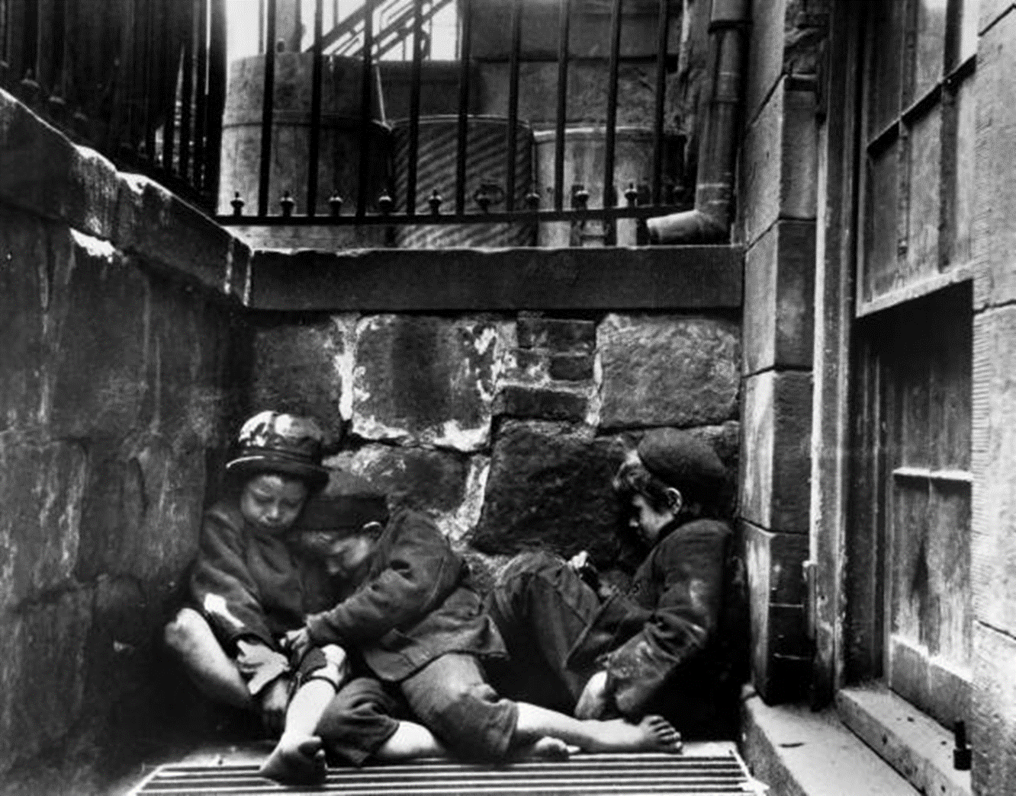
_________________ Photography is pictures of people. Nadar was the first photographer to ____________ people, use _____________ lighting, and invented _________ photography.  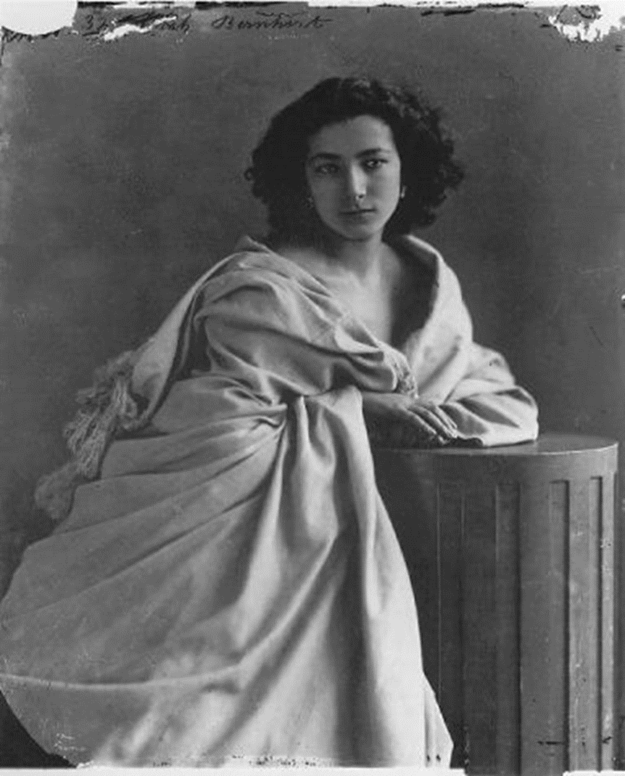  Art Photography began in the _____________. Photographers strived to capture __________ beauty.  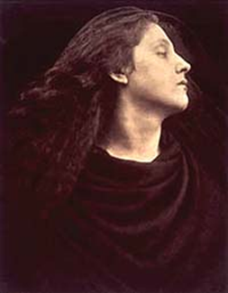 | Your Assignment  Use whatever picture taking device you have to create a trick picture, using object placement and foreground. Either develop your image or send me a digital copy. Make sure to get the clearest image possible for your device.

Grid Project

You will first create a grid of 1 inch boxes on your paper.

Make Marks every inch.
Then connect the lines using a ruler.

Turn your paper and repeat.
Make marks every inch.
The connect using a ruler.

Make sure you measure correctly.
Be sure to use the ruler to draw straight lines.

When you are finished. Find a portrait. The image must be a close up picture. Do not use an image that is far away or is of a whole body, head and some shoulders only. The more pixels, the better. Look for something above 700, the higher the better. Then print the picture off 8x10. Once you have your image. Grid it just like your drawing paper(draw a grid over top of the picture). This time you will make ½ inch boxes instead of 1 inch.

