Name___________
Date______________
Art Nouveau
Art Nouveau-__________________  Art should be _________________________ _____________________________________  ____________________Style was to counteract the cold steel look of the ___________________Age.  Aesthetics is ____________________________.  Art Nouveau wanted to make things __________________________________(make things pretty)  Decorative, ornamental, pretty, flowers, nature, sunsets… All descriptive words for _________________________  ____________________- most controversial artist of art nouveau movement.  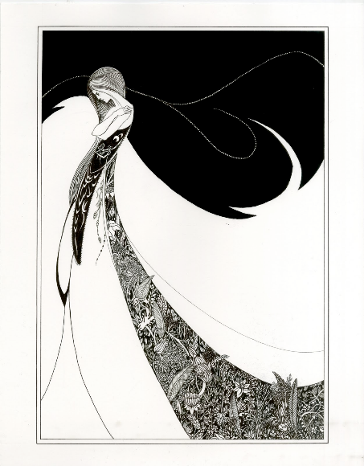  Instead of shading,_____________ are used to create value.  Flowers and other nature______________ are iconic of Art Nouveau.  _________________Two opposite elements used together to create one piece | ___________________ Louis Tiffany, son of Tiffany’s guy, stained glass. You can see his work at _____________ in Chicago.  Theophile Steilen- Miss. H’s fav  He made______________________  