Name_________
Date____________
Ancient Near East
Mesopotamia is Modern Day _______________________  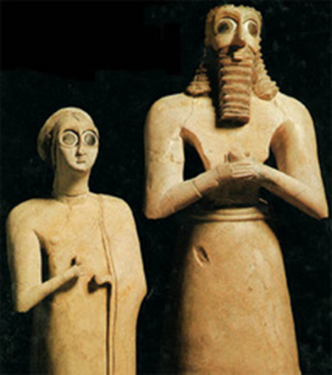  Votive Statues, Iraq __________BCE, Limestone  Placed on an ___________ to be worshipers in front of a God  Anyone who could afford it would have a ____________________ commissioned  Importance of approaching God with an attentive __________________.  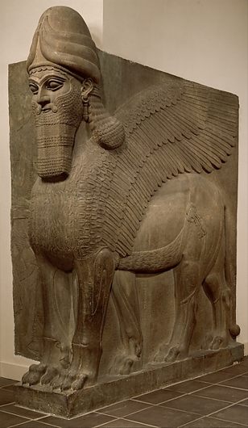  Human-Headed Winged Lion, Nimrud, _____BCE  horned _______ = divinity  ____________=power | They have five ______________ so that they appear to be standing firmly when viewed from the front but striding forward when seen from the side  They ________________ doorways of palaces.  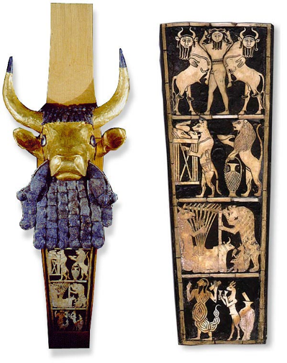  Bull lyre ___________ BCE  A lyre is a __________________.  Depicts ___________________

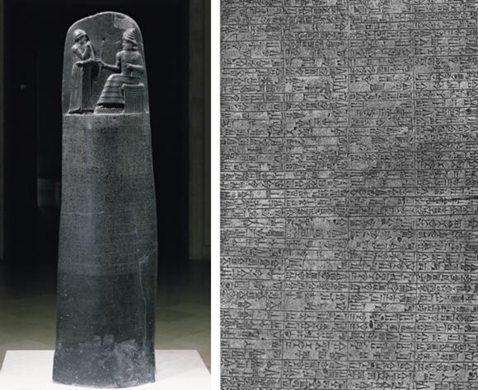  ________________of Hammurabi 1792-1750 BCE 7ft, Basalt  Hieratic Scale- __________=important  300 property, 68 domestic, 20 phys. Assault  Punishments based on wealth, class, gender  ____________ over poor, ______________ over slaves, ___________ over women  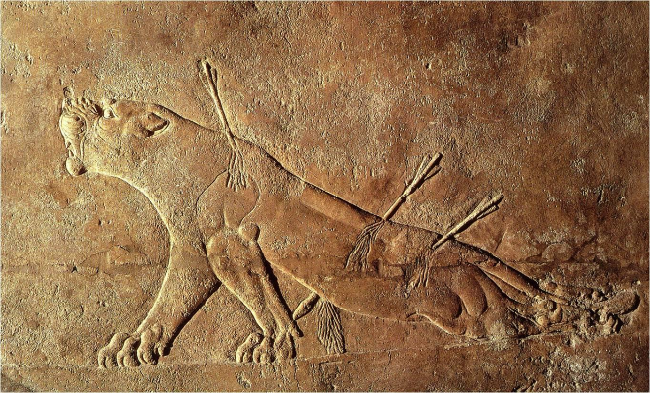  Dying lioness, Ninevah, 650 BCE  Symbolizes ____________________________ | Tower of Babel 3000-2000 BCE  “__________of the god”  ________________-Pyramid like structure made of mud bricks, baked bricks on outside to protect  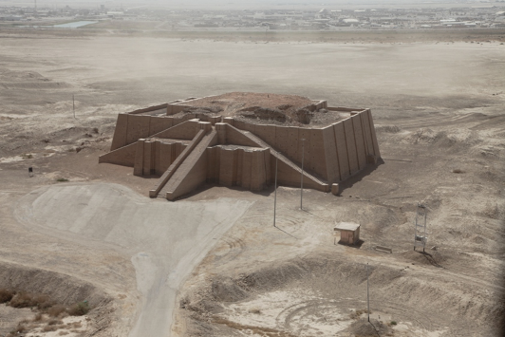  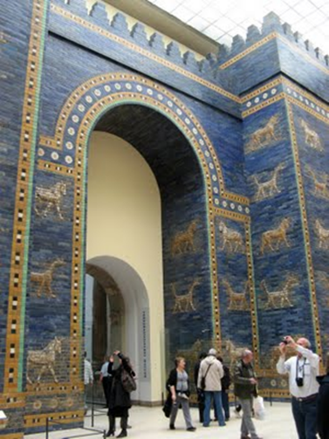  Different animals symbolize different _____________.  Stand for love, fertility, and war  Built for people to “_________________”

