Name___________
Art 1 Ancient Rome

Why did the Greeks add hair to the back of the neck? _______________  In the creation of Rome story Romulus and Remus were twins, raised by a __________.  1% of Romans live in ___________.  _____% of children live to adulthood  Languages teens learn: _____________&______________  Can’t do business deals until age _______  ______________ lived with their parents even after marriage  There were over _______ bathhouses in Rome. They were important places because _________________________________  Romans believed in __________ Gods. Roman Gods and _____________Gods with Roman names. To get to the underworld people needed __________ to cross the river.  Roman Art was realism. They wanted to show_____________________________  Only paintings on ________________ were considered “high art”  This boy was __________ painting. It was bandaged on a mummy. Encaustic painting is pigment mixed with __________________ | Mosaic- a picture made of _______________  found on __________, ______________, and ________________.  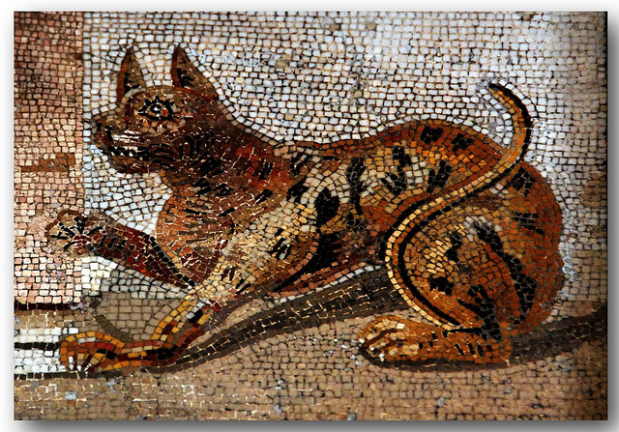  cat was important symbol for _____________. It was important to Romans because __________________________. _______________ cats are now protected in Rome.  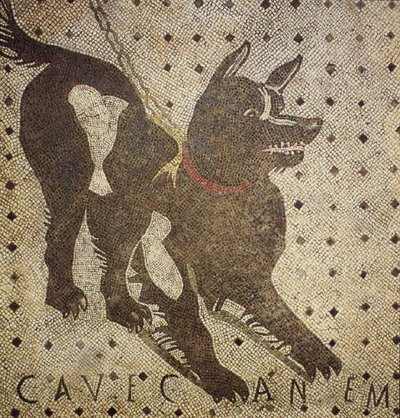  Dog mosaic said_____________________ and would have been____________________  What do we have like these today?______________________________

The arch was better than the post and lintel building because______________________.  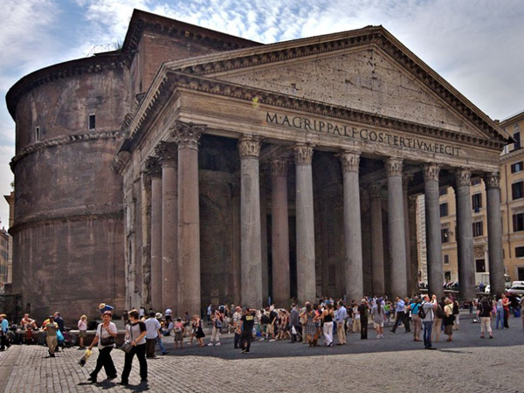  The pantheon is the best preserved ____________________________. It has been used since_______________________.  It has a large dome. The _______________ has never been covered.  The _____________________ was the main highway in Rome. __________miles long. Roads helped to ______________ the empire.  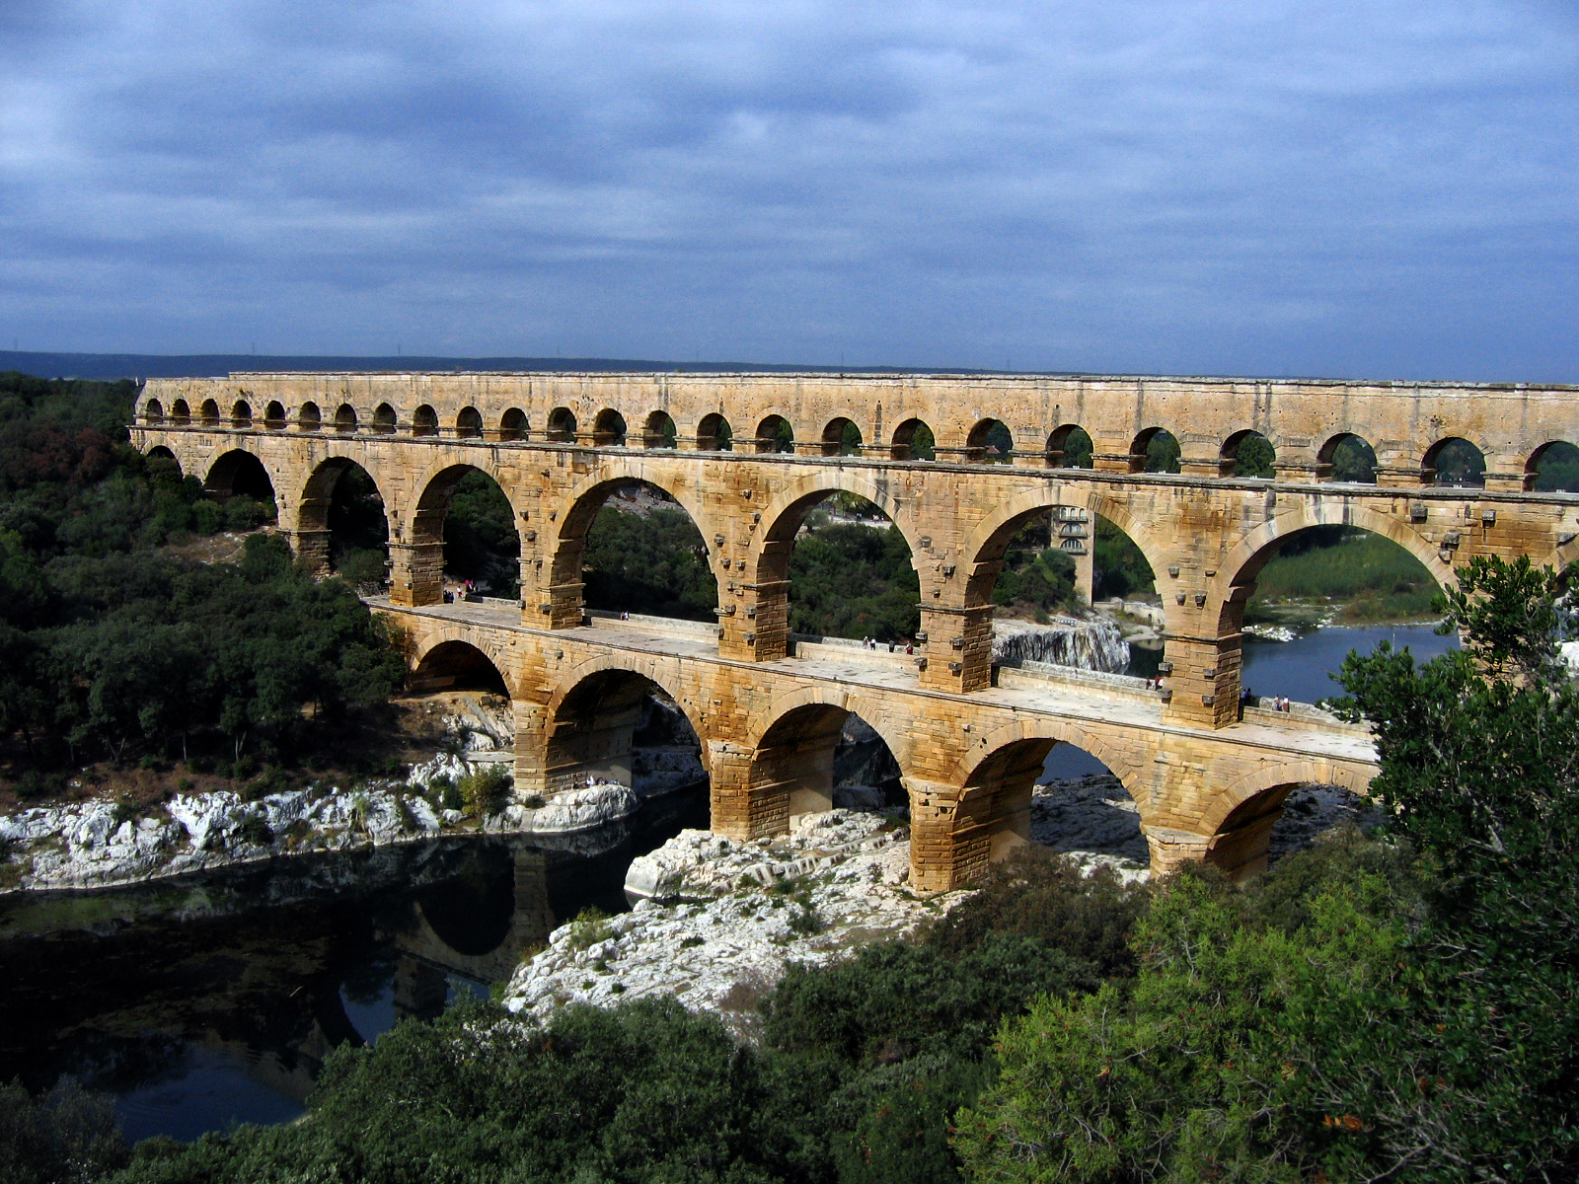  the aqueducts carried _________________ to ____________________________________ and _______________ away. They brought ___________ gallons of water to each of Rome’s 1 million residents. Whole system worked on _________________. | Colosseum:  Flavius ordered the Colosseum to be built but who built it?  How did spectators stay out of the sun?  Where did they get the water to flood the Colosseum?  Senators would have sat ___________________ and lower middle class____________________  Gladiators were _____________ or _______________________.

Gladiators vs football

Similarities | Differences

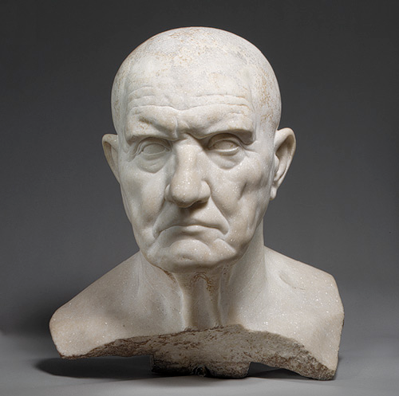  Why did people have busts of family members in their houses?  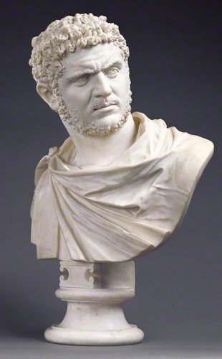 | 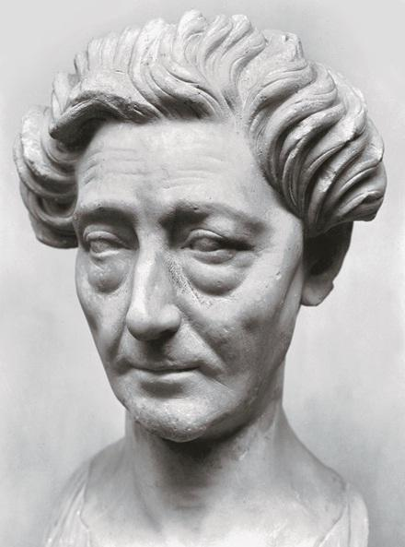  What makes this lady “fit” into Roman art rather than Greek art?  What kind of expression is on Caracalla’s face?  Why would he want all of his sculptures to look like this?  Why are ancient Roman sculptures more likely to look like the real person than Greek art?

