Egypt Notes
Day 2

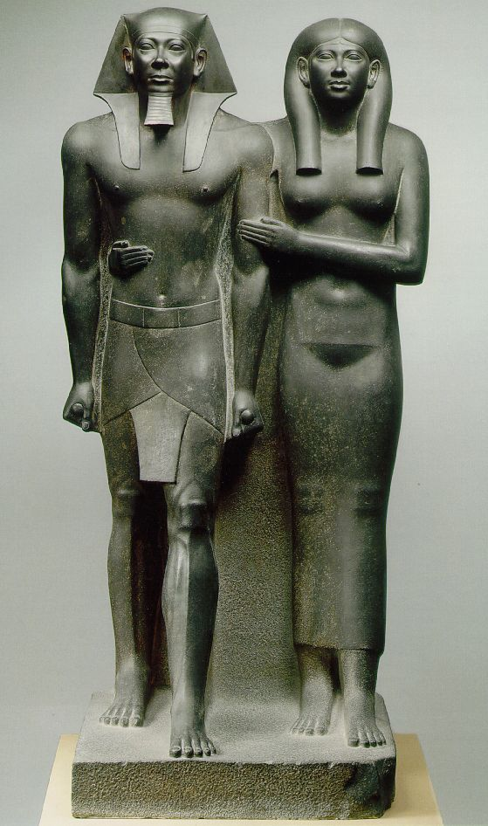Menkaura and his _______________. _______BCE  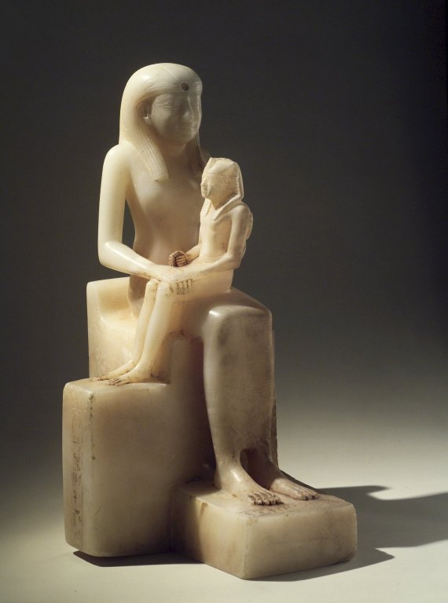  What do you see?  - Who’s important?  - Who is this Pepy?  - How do you know that?  - Why was this made? | 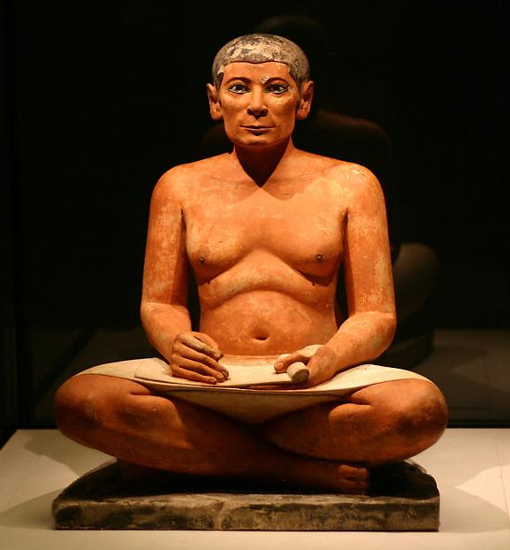  Seated Scribe, 2400 BC  What makes this sculpture look less formal?  Why were Hippo hunts important?  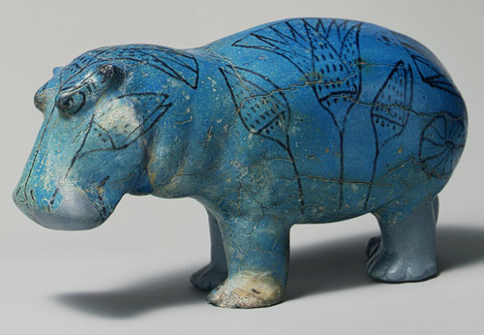  Why are there flowers painted on the side of the hippo?  King Tut  died when he was _____________  His tomb was found intact in _____________

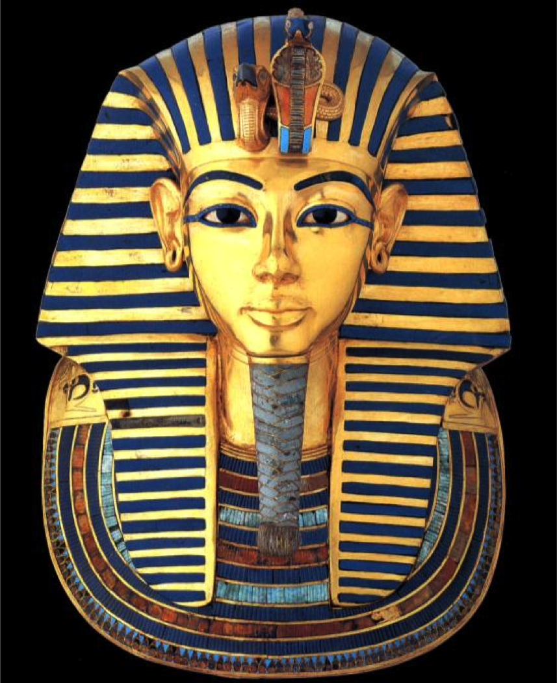
2014 __________ testing
found his father is king Akhenaten and his mother is Akhenaten's __________

Tut may have died from the combination of _____________ and bone disease

he also had a _____________ and was buried with over a 100 _________________

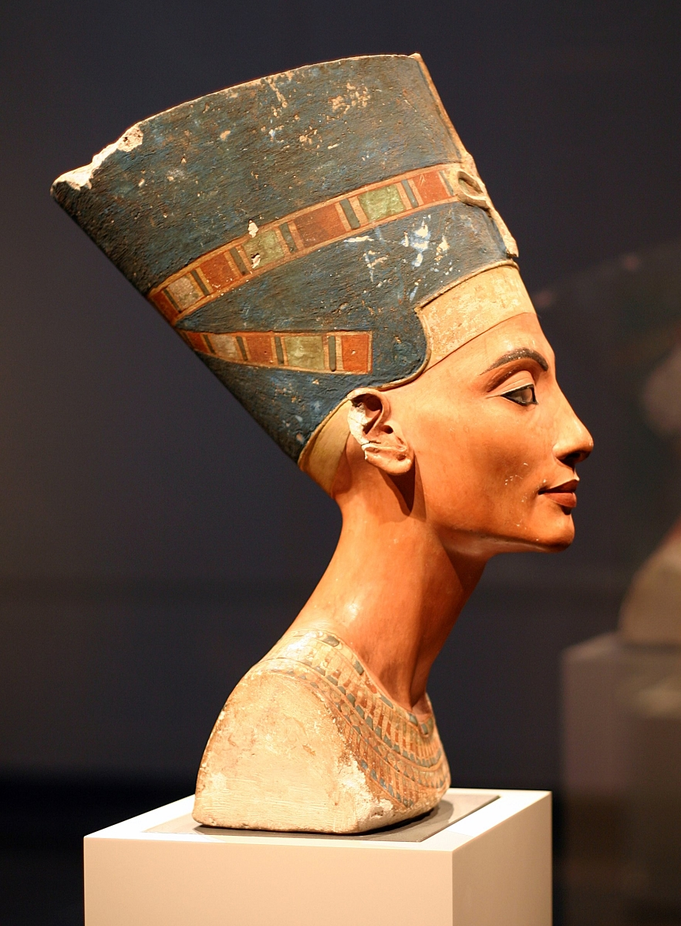
________________ was King Tut’s step mother.

Her name means “a __________________ has come”

