Name____________

Art 1
Ancient Egypt Day 1

Art is about _________________.  Everything, nature and human activities were part of a grand design of balance and ____________________  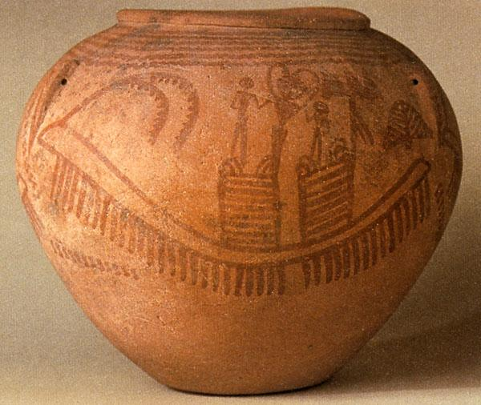  Depicts a _________________  Zig-zags at the top =__________________  How can you tell people are mourning?___________________________  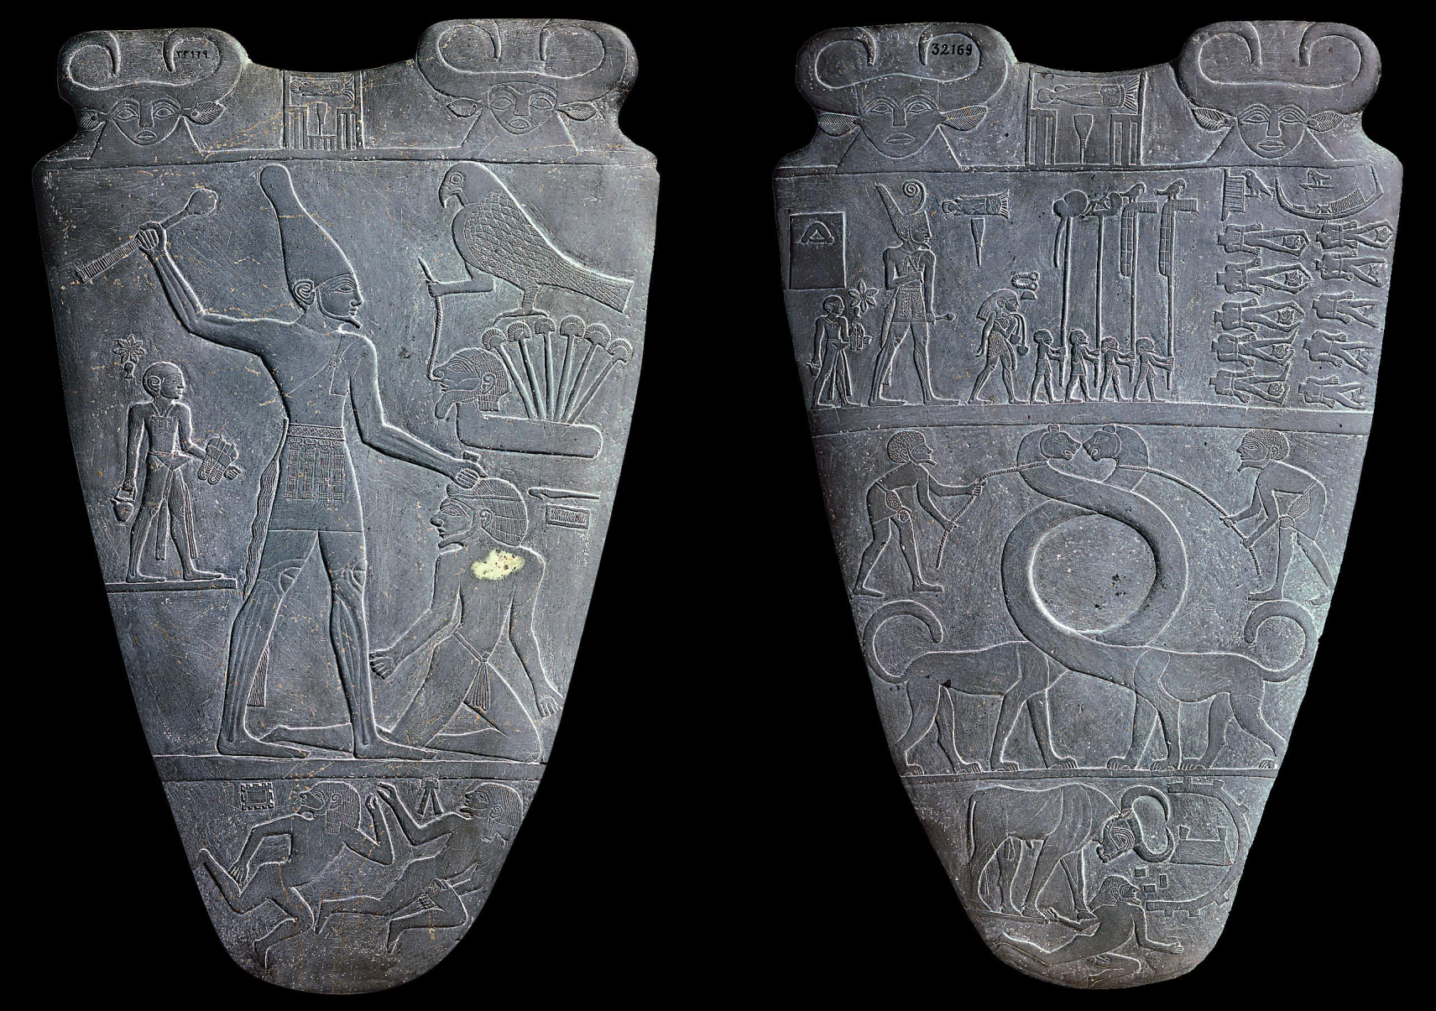  Used for _________________________  Bull stand for whom?________________ | 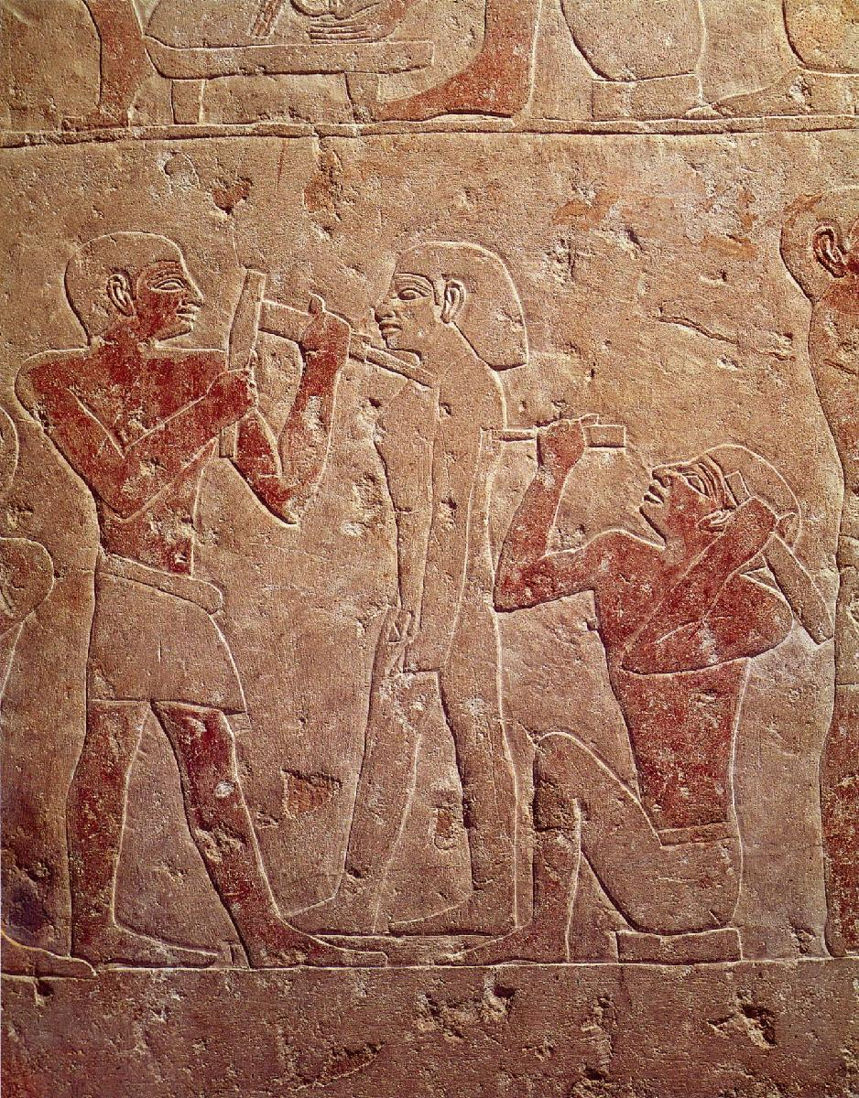  Why are body parts turned?______________  The formula artists used to create work was called? _____________________  Ka=___________________  Why did the pyramids have sloping sides?_______________  Movie:  What color were the pyramids originally? ___________________  What does the Great Sphinx face?  ________________________

