Name ____________
Date____________
Art 1
Notes Ancient Europe
Prehistory is a time of life before __________________. People were creating; ________________, _______________, and ____________________.  The earliest upright human species was ___________________________.  It is called the stone age because _____________________ was used to create tools, weapons, and figurines.  Most art will depict __________________ because ___________________________________  Sculpture is ___________ art. Earliest sculptures are from _______________BCE.  Sculpture in the round-_____________________________________  Relief sculpture-_______________________  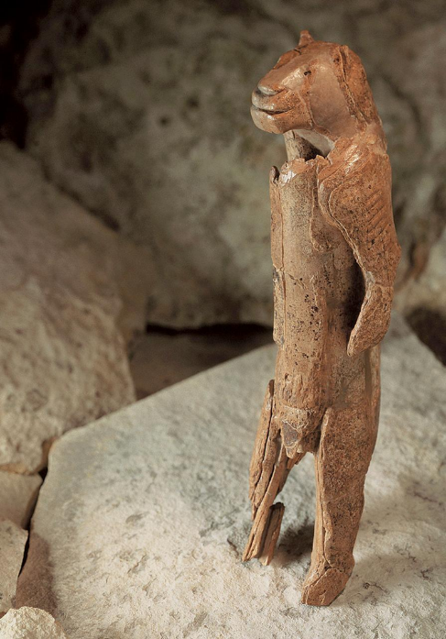  Proves sophisticated _________________________________ | 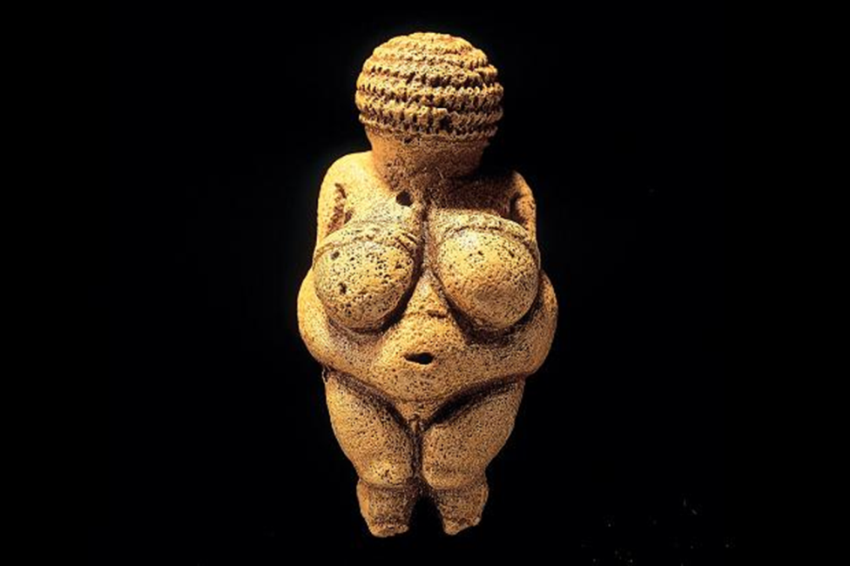  Most famous Prehistoric art_______________________________ 22,000 BCE. Curves=______________________________  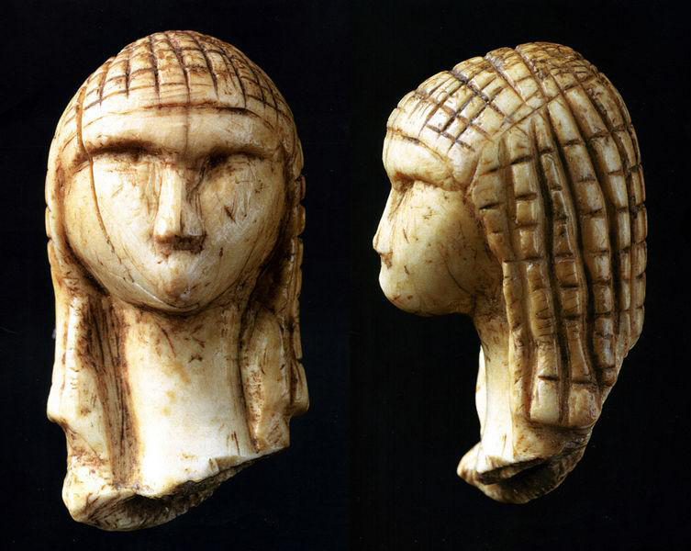  Woman from Brassempouy.  ______________________-could be any woman. Stereotypical features  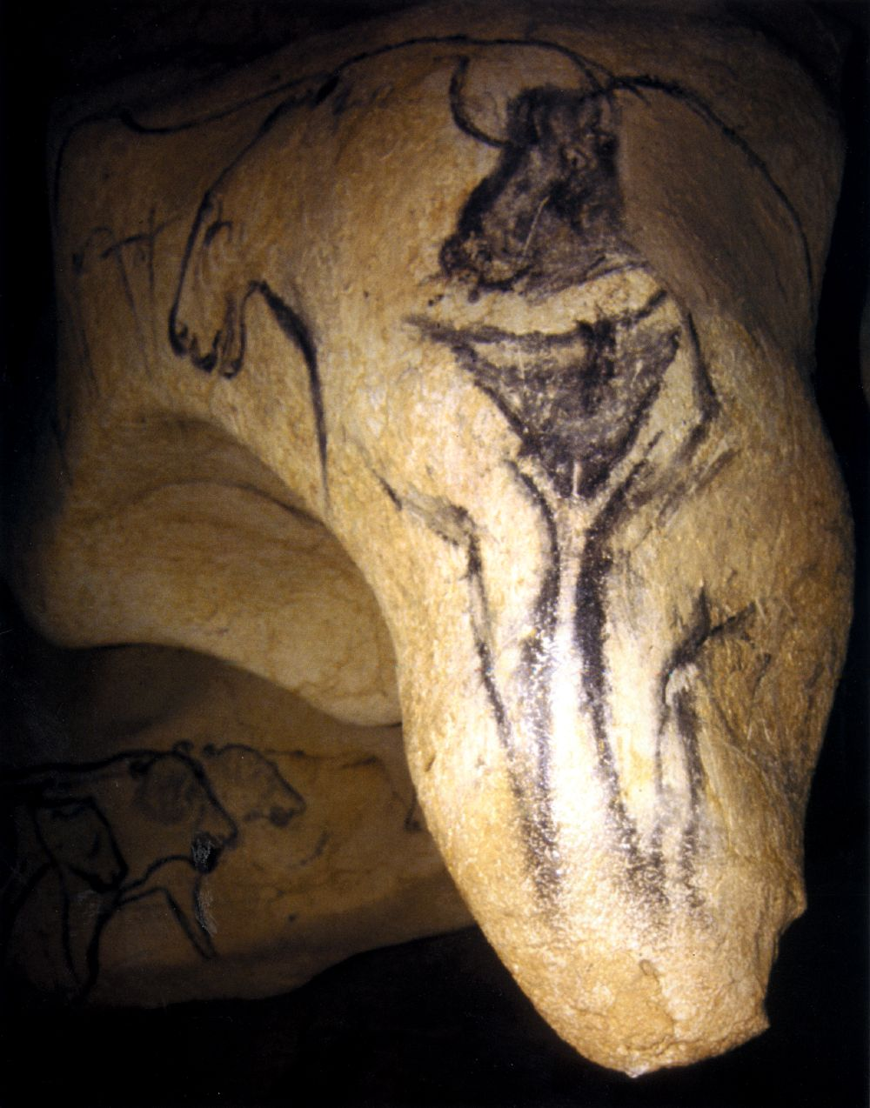  ___________________ is the earliest cave system. 28,000-10,000 BCE  How do we know it holds a special meaning to people? ___________________________  _____________________________________

Two Techniques artists used to paint images on walls:  __________________________________  __________________________________  Most cave art depicts _______________  Lascaux Cave system’s bird headed man seems to tell a _________________________  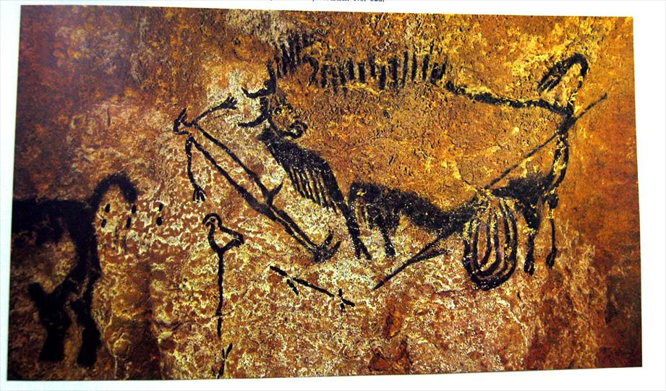  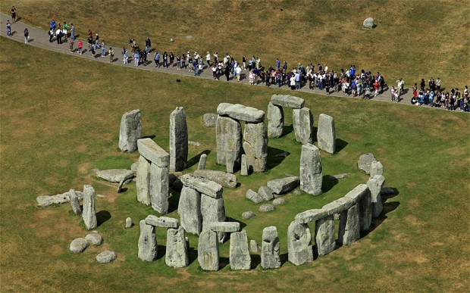  ____________________________, Salisbury Plain, England. Made from stone quarried over ______________________ away. | Stonehenge was more than just the circle, it was a whole site that took over ________ years to build  1 Theory__________________ powers  people would ____________ in water poured over the rocks  Amesbury _______________- buried near by, would have been in a lot of pain  Traveled over _______________miles  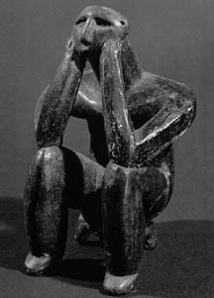Ceramics would have been made from clay that was mixed with ____________ and bone______________  First vessels were created at about _________________ BCE

